2 – Data Processing
2.27 You have responded you have a process to ensure the PI used or produced by your asset is as accurate, complete and up-to-date as is necessary for the purposes for which it is to be used.
We access PI from two sources:
- Realtime direct API calls to Unified Profile and Your Learning. Since we are pulling data in real time from those maintained API calls the asset is ‘as accurate, complete and up-to-date’
- We do store PI data in our Mongo database for certain applications. Each of these applications uses API endpoints we have created to update records on a regular basis.
- We have a data retention policy that will remove PI for any employee when we identify they have left IBM
2 – Data Processing
2.31 You have responded that a retention period has been identified and documented
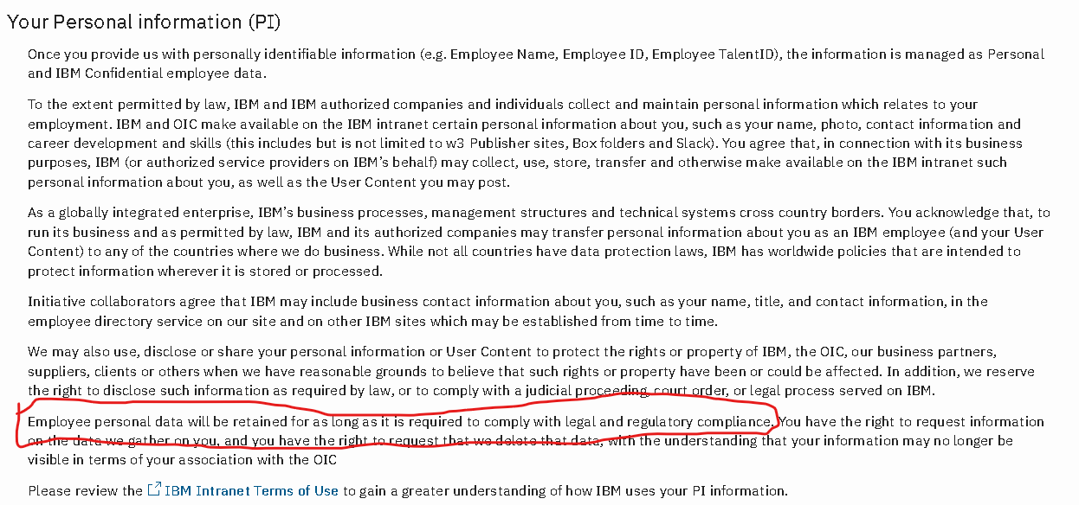
3 – Notice
3.7 Attach a copy of the privacy notice(s) you are relying on and highlight the section of that privacy notice upon which you are relying.
Attached is a screenshot of our Privacy notice page:
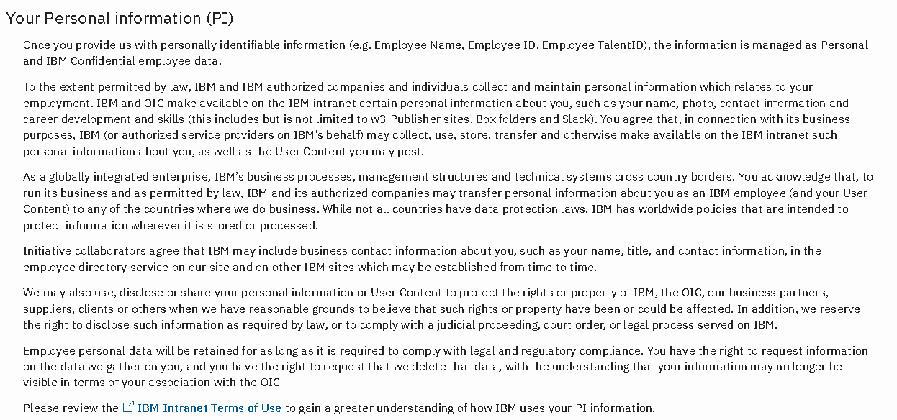
The link to this document would be in the footer of every page on our website i.e.


